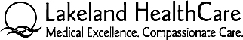

Parent/Guardian Consent for Observation

I give permission for my son or daughter ____________________, (a minor) to participate in an observational experience at Lakeland HealthCare. I release Lakeland HealthCare from all claims that may arise from this observational experience. I understand this is an observational experience only and there will be no patient care given by my son or daughter.
__________________________________________
Parent/Guardian Name (Printed)

________________ ________________ ________________ ________________
(Home) (Work) (Cell) (Other)
__________________________________________
Parent/Guardian Name (Signature)

